Web Design and Development

4COSC011C.3

Report

Student Name: Radil Rupasinghe

Student ID: 20220571 / w1998844

Group Number: E4

Student Role: 2

1. Introduction 2

2. Technical Discussion 4

Student 2 Tasks: 4

3. Webpage Validation Statement 4

4. Janet 4

References 4

Appendices 4

Appendix A: Code 4

Appendix B: Screenshots 5

Appendix C: Screenshots - Webpage Validation Evidence 5

Appendix D: Individual Statement 6

Appendix E: Task Completion Checklist 7

# Introduction

1. **Student details and tasks allocated.**

|  |  |  |
| --- | --- | --- |
| Topic: BehindTheCurtain | | |
| **Name** | **Student Role** | **Tasks** |
| Thanuga Rodrigo | Student 1 | Presentation page, But products page |
| Radil Rupasinghe | Student 2 | Main page, comments form, external css |
| Udula Lokitha | Student 3 | Quiz page, Student details page |
| Sehandu Siriwardhana | Student 4 | Gallery page, Site map |

The main topic that our group members selected is entertainment and the idea was to make the website about performing arts. The reason for this name for the website was that every practice, every hardship went behind the curtain is unleashed Infront of the spectators in the most elegant way is the way of performers.

1. **Contributions in the group meetings**

| 1. **Group Coursework Meetings** (minimum 5 meetings, e.g., one per week) | | |
| --- | --- | --- |
| **1** | **Date & Time** | **15th of June 2023** |
| **Objective:** | **Finding out the group members and had a general discussion about the project and dividing the roles** |
| **Attended:** | **Yes** |
| **Your Contribution:** | **Came up with innovative and eye-catching ideas for designing the website** |
| **2** | **Date & Time:** | **23th of June 2023** |
| **Objective:** | **Gathering information for our individual content pages and getting ideas about styling and giving colour schemes and background imaging** |
| **Attended:** | **Yes** |
| **Your Contribution:** | **Giving ideas about colour schemes and proposing eye-catching background images for the website** |
| **3** | **Date & Time** | **8th of July 2023** |
| **Objective:** | **To check the progress of the completed things** |
| **Attended:** | **Yes** |
| **Your Contribution:** | **Checked other students progress and give ideas to add and places needed to be removed** |
| **4** | **Date & Time** | **17th of July 2023** |
| **Objective:** | **Fix the errors come by when linking the navbar and footer to the pages** |
| **Attended:** | **Yes** |
| **Your Contribution:** | **Fixed the errors which occurs when navbar and footer linked to the page** |
| **5** | **Date & Time** | **21st of July 2023** |
| **Objective:** | **Linking all the pages of others students and making the website fully functional** |
| **Attended:** | **Yes** |
| **Your Contribution:** | **Linked all the pages including individual pages and fix the errors occurred after linking the pages** |

# Technical Discussion

## Student 2 Tasks:

1. **Main (home) page**

Main page was designed using html and CSS by linking the navigation bar and the footer to it. An eye-catching brief introduction to performing is given in the left side and it is left aligned using CSS display in line property and in the right to it is the four cards for the individual pages of the group members. Two cards are in the top while the other two cards are in the bottom which is assigned using CSS margin properties. Also, a hover effect can be seen in the cards. Those cards have been made a link to personal sites by creating individual classes by using separate divs and an anchor tag is placed on top of all divs which link to all sites. Cards include several images for each div and it is assigned using separate ids for each div. and also those cards include the topic and a slight description about the details of it in a meaningful way. The topic is written in a h4 and the description is in a p tag. All of them are styled using CSS.

The theme for the web page is dark themed and used purple for all the hovers.

After scrolling down from the Above page there is another page which attracts the user to the buy products page which includes two of the best-selling products gives as cards which is designed the same as before. The topic of the page is given using a h2 tag and it is designed using CSS in the external CSS file created by me.

After that page there is a page which links to the quiz page which also includes the topic as a h2 tag and a slight description about how to navigate in a p tag which are also designed in the eternal CSS file created by me (Main.css). This also includes a button created by an anchor tag and designed it as a button using CSS.

After all that a slight margin to catch the eye of the user to fill out the feedback form was created which links to the Comments form in the end of the page.

At last, there is the footer which was designed by the whole group is added which has links to page editor, home page, About us page, sitemap and gallery page. The footer is also under the theme color which has black in the background and texts in white which has hover effect of the purple color we used in the whole website (#6527BE).

All above mentioned parts have separate background images which are also assigned using CSS.

1. **Site navigation bar**

Navigation bar is created using an un-ordered list by giving the page name as lists items and changing its display property to inline which makes it in a line. An active class is given to the active page, and it is created to be highlighted in the theme colour using CSS. And, a hover effect for each list item is given in the navbar CSS file which is also in the theme colour. The speciality of this navbar is that this navigation bar is made responsive using media queries and JavaScript with the help of w3schools and MDN documentation.

1. **External style sheet for website (with style guide)**

The whole idea of this is to link this to every page of the whole group and this to have the foundation of the design template of the website. This includes all the styles for texts tags such as h1, h2, h3, body, p tags and much more. All the texts are designed to be in white colour, so it matches the dark theme we went in the website. Also, mainly it includes designs that are to be included in the whole thing which is describes using *.

1. **Comments Form**

The form is created using form tags in html and it is placed inside a div. The form contains ratings from 0 – 10 and a description for the user to enter about the rating in a textarea and two dropdown menus on what media were used to fill the form and what media will be preferred to be used by the user if he ever uses this again.

The div is given some border-radius and it has a faded colour which makes it seem to be opacified with the background image. All texts inside are in black colour. The radio buttons are made to be horizontally.

This form includes two buttons which is a submit button and a reset button. These buttons are given a border-radius and also the theme purple colour and it is also given a hover state to be a slight grey colour.

A thankyou message is also created to be displayed when submit button is clicked and it is closed when it’s OK button is clicked. All this is operated using JavaScript.

When the rating and description is not given an alert pop up to the user saying them to fill the above which is also created using JavaScript which is made by making variables and assigning the input values to the variables and then by using if statements it is validated.

To email the form to our email I used a site called FormSubmit.co where the details are emailed in an organized way.

This has the navigation bar linked to all the sites and also the footer.

1. **Page Editor Page**

This also have the navigation bar linked to all the sites and also the footer.

This page has a picture of myself given 50% border-radius to make it a circle and then my student details and then my tasks listed one by one including links to all the sites and a slight description about how I made it. All texts are aligned to centre and all parts are separated from a horizontal rules which has a smaller width.

1. **Extra content page relevant to topic**

The topic I selected for performing arts is dancing and I designed this page to have Dancing in a h2 tag in the centre and a point wise description about dancing which has a background image which is added using CSS. Then using another div which has a background colour of #161616 is added with a topic in h2 and three cards which is made in the above-mentioned manner is added to it which has three types of international dances which has Kandyan which is Sri Lankan and then Ballet and Kathakali which is Indian. Those three cards are linked to their own web pages and it has the same kind of CSS which is used in the first div in the individual content page.

The main individual content page has a back to top link and also the other three sites have a link to come back to the main content page.

All these sites include the navigation bar as well as the footer.

# Webpage Validation Statement

* Home page (homepage.html)
* Query Form / Comments form (queryForm.html)
* Page editor (student2PageEditor.html)
* Additional content page (dance.html) – and its other pages.

# Janet

# The website was created in compliance with all relevant requirements and does not store any personal data of users, such as usernames, passwords, or payment card details. It only retains contact information and order details solely for the purpose of managing the shopping process. The development process ensured that no trademarks, copyrights, or patents were infringed upon, and proper permissions and licenses were obtained for any copyrighted content used.

# Furthermore, the website fully adheres to Janet Rules and Regulations, and strict compliance with JANET's Acceptable Use Policy is maintained by ensuring no objectionable, abusive, or unlawful content or services are provided to users. The user information is securely discarded once it is no longer needed, following established data retention and destruction standards.

# References

FormSubmit to submit entered details in the query form to email - <https://formsubmit.co/>

W3Schools – <w3schools.com>

MDN documentation - <https://developer.mozilla.org/>

# Appendices

## Appendix A: Code

* **homepage.html**

<!DOCTYPE html>

<html lang="en">

<head>

<meta charset="UTF-8">

<meta name="viewport" content="width=device-width, initial-scale=1.0">

<link rel="stylesheet" href="Main.css">

<link rel="stylesheet" href="homePage.css">

<link rel="stylesheet" href="navbar.css">

<link rel="stylesheet" href="footer.css">

<link rel="icon" type="image/png" href="favicon_io/favicon.ico" />

<title>BehindTheCurtain</title>

</head>

<body>

<div class="container">

<!-- navbar -->

<div class="navbar">

<nav class="navbar">

<label for="toggle" class="hamburger">

<span class="bar"></span>

<span class="bar"></span>

<span class="bar"></span>

</label>

<input type="checkbox" id="toggle"/>

<ul class="nav-menu">

<li class="nav-item"><a class="nav-items active" >Home</a></li>

<li class="nav-item"><a class="nav-items" href="#">Buy products</a></li>

<li class="nav-item"><a class="nav-items" href="queryForm.html">Query form</a></li>

<li class="nav-item"><a class="nav-items" href="#">Quiz</a></li>

<li class="nav-item"><a class="nav-items" href="#">About Us</a></li>

<li class="nav-item"><a class="nav-items" href="#">Site map</a></li>

<li class="nav-item"><a class="nav-items" href="#">Gallery</a></li>

</ul>

<div class="logo">BehindTheCurtain</div>

</nav>

</div>

<!-- Main page containing all individual pages -->

<div class="Main-page">

<div class="col">

<h1>Performing</h1>

<p class="home-description">In the realm of performing arts, I find myself alive, transported to a place where the ordinary is transformed into something extraordinary. The enchanting melodies of music, the graceful movements of dance, the compelling stories brought to life through theater and the comedic brilliance of stand-up comedy —they all captivate my heart and awaken my soul.</p>

</div>

<div class="col">

<a href="#">

<!-- Individual pages -->

<div class="card-1">

<h4>Theatre</h4>

<p>Emotional storytelling, live performances, dramatic artistry, immersive experiences, collaborative creativity.</p>

</div>

</a>

<a href="dance.html">

<div class="card-2">

<h4>Dance</h4>

<p>Rhythmic expression, joyful movement, captivating performances, cultural artistry, liberating creativity.</p>

</div>

</a>

<a href="#">

<div class="card-3">

<h4>Music</h4>

<p>Melodic harmony, universal language, emotional expression, rhythmic diversity, timeless enchantment.</p>

</div>

</a>

<a href="#">

<div class="card-4">

<h4>Comedy</h4>

<p>Witty humor, laughter-inducing tales, audience interaction, comedic storytelling, spontaneous hilarity.</p>

</div>

</a>

</div>

</div>

</div>

<!-- A link to buy products page -->

<div class="buyProducts">

<h2>Shop the latest products related to performing from us</h2>

<div class="description-buyProducts">

<p>All products related to Dance, Music, Theatre and Comedy are in the reach of your finger tips. Click on the items to check out more.</p>

</div>

<a href="#">

<div class="item" id="item1">

<p>Lastest Guitars</p>

</div>

</a>

<a href="#">

<div class="item" id="item2">

<p>Dancing costumes</p>

</div>

</a>

<div class="description-buyProducts">

</div>

</div>

<!-- A link to quiz page -->

<div class="quiz">

<h2>Check your knowledge about Performing arts right now</h2>

<a href="#" class="button">Go to Quiz</a>

<p>Click the above button to go to the quiz</p>

</div>

<div class="queryForm">

<a href="queryForm.html"><h3>Spend some time to rate our website</h3></a>

</div>

<!-- Footer -->

<footer>

<div class="footer-content">

<a href="student2PageEditor.html" class="pageEditorName">Page Editor | Radil Rupasinghe</a>

<ul class="footer-links">

<li><a href="homePage.html">Home</a></li>

<li><a href="student2PageEditor.html">About</a></li>

<li><a href="#">Site Map</a></li>

<li><a href="#">Gallery</a></li>

</ul>

<p class="copyright">&copy; 2023 BehindTheCurtain. All rights reserved.</p>

</div>

</footer>

<!-- Javascript for navbar -->

<script src="navbar.js"></script>

</body>

</html>

* **homepage.css**

body{

padding: 0;

margin: 0;

}

.Main-page{

background-image: url(Images/Background-Main.jpg);

background-attachment: fixed;

background-repeat: no-repeat;

background-size: cover;

background-position: center ;

display: flex;

height: 100vh;

align-items: center;

justify-content: center;

}

.col{

flex-basis: 50%;

}

h1{

padding-left: 10px;

}

.home-description{

padding-left: 10px;

}

p{

line-height: 15px;

color: white;

}

.card-1, .card-2, .card-3, .card-4{

width: 200px;

height: 230px;

display: inline-block;

border-radius: 10px;

padding: 15px 25px;

box-sizing: border-box;

cursor: pointer;

margin: 30px 75px;

background-image: url(Images/pic-1.png);

background-position: center;

background-size: cover;

transition: transform 0.5s ;

}

.card-1{

background-image: url(Images/Theatre2.jpg);

}

.card-2{

background-image: url(Images/Dance.jpg);

}

.card-3{

background-image: url(Images/Music.jpg);

}

.card-4{

background-image: url(Images/Comedy-3.jpg);

}

.card-1:hover{

transform: translateY(-10px);

}

.card-2:hover{

transform: translateY(-10px);

}

.card-3:hover{

transform: translateY(-10px);

}

.card-4:hover{

transform: translateY(-10px);

}

h4{

color: white;

text-shadow: 0 0 2px #999;

}

.card p{

text-shadow: 0 0 15px #000;

font-size: 8px;

}

.buyProducts{

background-image: url(Images/buyProducts-Main.jpg);

background-attachment: fixed;

background-repeat: no-repeat;

background-size: cover;

background-position: center ;

text-align: center;

}

.buyProducts h2{

padding-top: 25px;

color: white;

}

.buyProducts p{

padding-top: 50px;

font-size: 20px;

font-weight: 50;

}

.item{

display: inline-block;

margin: 90px 50px;

padding: 125px 75px;

border-radius: 6px;

}

.item p{

margin: 20% auto;

}

#item1{

background-image: url(Images/Music.jpg);

}

#item2{

background-image: url(Images/Dance.jpg);

}

.item:hover{

transform: translateY(-10px);

}

.quiz{

background-image: url(Images/Quiz.jpg);

background-attachment: fixed;

background-repeat: no-repeat;

background-size: cover;

background-position: center ;

text-align: center;

}

.quiz h2{

padding-top: 50px;

color: white;

margin-bottom: 255px;

}

.button{

padding: 20px;

width: 15%;

border-radius: 50px;

border-style: none;

font-size: 30px;

font-weight: 30;

background-color: #6527BE;

color: white;

}

.button:hover{

background-color: white;

color: black;

}

.button:active{

background-color: #6527BE;

color: white;

}

.quiz p{

margin-top: 30px;

padding-bottom: 125px;

font-size: 20px;

font-weight: 50;

}

.queryForm h3{

background-color: black;

}

.queryForm{

margin: 10px;

text-align: center;

}

.queryForm h3:hover{

background-color: #6527BE;

}

* **Main.css**

*{

text-decoration: none;

list-style: none;

box-sizing: border-box;

}

body{

font-family: 'Montserrat', sans-serif;

background-attachment: fixed;

background-repeat: no-repeat;

background-size: cover;

background-position: center ;

}

p{

font-size: 80%;

}

h1{

font-size: 100px;

color: white;

}

h2{

font-size: 70px;

color: white;

}

h3{

font-size: 40px;

color: white;

}

* **navbar.css**

*{

padding: 0;

margin: 0;

text-decoration: none;

list-style: none;

box-sizing: border-box;

}

body{

font-family: 'Montserrat', sans-serif;

}

nav{

position: fixed;

background: black;

height: 80px;

width: 100%;

display: flex;

justify-content: space-between;

align-items: center;

}

.logo{

color: white;

font-size: 25px;

line-height: 80px;

padding: 0 20px;

font-weight: bold;

}

.hamburger{

display: none;

flex-direction: column;

cursor: pointer;

}

.hamburger span{

height: 3px;

width: 25px;

background: white;

margin-bottom: 4px;

border-radius: 3px;

}

.nav-menu{

display: flex;

}

.nav-menu li{

display: inline-block;

margin: 0 10px;

}

.nav-menu li a{

color: white;

font-size: 17px;

padding: 7px 13px;

border-radius: 3px;

text-transform: uppercase;

text-decoration: none;

}

a.nav-items:hover, a.nav-items:active{

background: #6527BE;

transition: .5s;

}

.active{

background-color: #6527BE;

}

#toggle{

display: none;

}

@media (max-width: 768px) {

.logo{

padding-left: 10px;

}

.nav-menu{

display: none;

}

.hamburger{

display: flex;

}

#toggle{

display: none;

}

.nav-menu.active{

display: flex;

flex-direction: column;

background: #6527BE;

position: absolute;

top: 80px;

left: 0;

width: 100%;

padding: 20px;

}

.nav-menu li{

margin-right: 0;

margin-bottom: 10px;

}

.nav-menu li:last-child{

margin-bottom: 0;

}

.nav-menu li a{

padding: 10px;

}

}

* **navbar.js**

const hamburger = document.querySelector(".hamburger")

const navMenu = document.querySelector(".nav-menu")

hamburger.addEventListener("click", () => {

hamburger.classList.toggle("active")

navMenu.classList.toggle("active")

})

* **footer.css**

body {

margin: 0;

padding: 0;

}

/* Footer styles */

.pageEditorName{

float: left;

}

a{

color: white;

}

a:hover{

color:#AA77FF;

}

footer {

width: 100%;

background-color: #000;

color: #fff;

padding: 20px;

text-align: center;

}

.footer-content {

display: flex;

flex-direction: column;

align-items: center;

}

.footer-links {

list-style: none;

padding: 0;

margin-top: 10px;

}

.footer-links li {

display: inline-block;

margin: 0 10px;

}

.footer-links li a {

color: #fff;

text-decoration: none;

}

.footer-links li a:hover {

text-decoration: none;

color: #AA77FF;

}

.copyright{

margin-top: 10px;

}

* **queryForm.html**

<!DOCTYPE html>

<html lang="en">

<head>

<meta charset="UTF-8">

<meta name="viewport" content="width=device-width, initial-scale=1.0">

<link rel="stylesheet" href="Main.css">

<link rel="stylesheet" href="queryForm.css">

<link rel="stylesheet" href="navbar.css">

<link rel="stylesheet" href="footer.css">

<link rel="icon" type="image/png" href="favicon_io/favicon.ico" />

<title>BehindTheCurtain</title>

</head>

<body>

<div class="container">

<!-- Navbar -->

<div class="navbar">

<nav class="navbar">

<label for="toggle" class="hamburger">

<span class="bar"></span>

<span class="bar"></span>

<span class="bar"></span>

</label>

<input type="checkbox" id="toggle"/>

<ul class="nav-menu">

<li class="nav-item"><a class="nav-items" href="homePage.html">Home</a></li>

<li class="nav-item"><a class="nav-items" href="#">Buy products</a></li>

<li class="nav-item"><a class="nav-items active" href="queryForm.html">Query form</a></li>

<li class="nav-item"><a class="nav-items" href="#">Quiz</a></li>

<li class="nav-item"><a class="nav-items" href="#">About Us</a></li>

<li class="nav-item"><a class="nav-items" href="#">Site map</a></li>

<li class="nav-item"><a class="nav-items" href="#">Gallery</a></li>

</ul>

<div class="logo">BehindTheCurtain</div>

</nav>

</div>

<br><br><br><br><br><br><br>

<div class="ending bottom-margin">

<!-- Form -->

<div class="form">

<form method="POST" action="https://formsubmit.co/radil.20220571@iit.ac.lk" name="feedback" onsubmit="return validateForm()">

<label >How satisfied were you with our website today? Choose from 0 to 10.</label>

<br>

<div class="rating-container">

<input type="radio" name="rating" value="0"><p>0</p>

<input type="radio" name="rating" value="1"><p>1</p>

<input type="radio" name="rating" value="2"><p>2</p>

<input type="radio" name="rating" value="3"><p>3</p>

<input type="radio" name="rating" value="4"><p>4</p>

<input type="radio" name="rating" value="5"><p>5</p>

<input type="radio" name="rating" value="6"><p>6</p>

<input type="radio" name="rating" value="7"><p>7</p>

<input type="radio" name="rating" value="8"><p>8</p>

<input type="radio" name="rating" value="9"><p>9</p>

<input type="radio" name="rating" value="10"><p>10</p>

</div>

<label for="description">Please could you tell us your reasons for giving this rating?:</label>

<br>

<textarea id="description" name="description" rows="4" cols="50"></textarea>

<label for="reason1">How did you complete this task today?</label>

<br>

<select id="reason1" name="How the task was completed">

<option value="Phone" id="Phone">Phone</option>

<option value="Website" id="Website">Website</option>

<option value="Web chat" id="Web_chat">Web chat</option>

<option value="Email" id="Email">Email</option>

<option value="Social media" id="Social_Media">Social media</option>

</select>

<label for="reason2">If you have to complete this task again, How would you prefer to do it?</label>

<br>

<select id="reason2" name="How the task will be completed">

<option value="Phone" id="Phone-">Phone</option>

<option value="Website" id="Website-">Website</option>

<option value="Web chat" id="Web_chat-">Web chat</option>

<option value="Email" id="Email-">Email</option>

<option value="Social media" id="Social_Media-">Social media</option>

</select>

<input type="reset" value="Reset">

<input type="submit" value="Submit" onclick="openPopup()">

<div class="popup" id="popup">

<img src="Images/tick.png" alt="tick">

<h2>Thank you!</h2>

<p>Your rating has been successfully submitted. Thank you!</p>

<button type="button" onclick="closePopup()">OK</button>

</div>

</form>

</div>

</div>

<!-- Footer -->

<footer>

<div class="footer-content">

<a href="student2PageEditor.html" class="pageEditorName">Page Editor | Radil Rupasinghe</a>

<ul class="footer-links">

<li><a href="homePage.html">Home</a></li>

<li><a href="student2PageEditor.html">About</a></li>

<li><a href="#">Site Map</a></li>

<li><a href="#">Gallery</a></li>

</ul>

<p class="copyright">&copy; 2023 BehindTheCurtain. All rights reserved.</p>

</div>

</footer>

</div>

<!-- Javascirpt for navbar and form -->

<script src="navbar.js"></script>

<script src="form.js"></script>

</body>

</html>

* **queryForm.css**

body{

padding: 0;

margin: 0;

background-image: url(Images/Background-Sub.jpg);

}

/* Form container styles */

.form {

position: inline;

max-width: 500px;

margin: auto;

padding: 50px 50px; /* Adjust the values here */

background-color: rgba(255, 255, 255, 0.9);

border-radius: 5px;

box-shadow: 0 0 10px rgba(0, 0, 0, 0.2);

}

/* Label styles */

label {

display: inline-block;

margin-bottom: 10px;

font-weight: bold;

}

/* Input styles */

input[type="radio"],

textarea,

select {

width: 100%;

padding: 10px;

border: 1px solid #ccc;

background-color: #f9f9f9;

color: #555;

margin-bottom: 15px;

border-radius: 5px;

}

textarea {

resize: vertical;

}

/* Button styles */

input[type="submit"],

input[type="reset"] {

background-color: #6527BE;

color: #fff;

border: none;

padding: 10px 20px;

cursor: pointer;

margin-right: 10px;

border-radius: 5px;

}

/* Input hover styles */

input[type="radio"]:hover,

textarea:hover,

select:hover {

background-color: #e0e0e0;

}

/* Button hover styles */

input[type="submit"]:hover,

input[type="reset"]:hover {

background-color: #555;

color: #fff;

}

/* Container margin */

.bottom-margin {

margin-bottom: 30px;

}

/* Rating container styles */

.rating-container {

display: flex;

justify-content: flex-start;

align-items: center;

margin-bottom: 15px;

}

/* Rating input styles */

.rating-container input[type="radio"] {

margin-right: 10px;

}

.popup{

width: 400px;

background: white;

border-radius: 6px;

position: absolute;

top: 0;

left: 50%;

transform: translate(-50%, -50%) scale(0.1);

text-align: center;

padding: 0 30px 30px;

color: #333;

visibility: hidden;

transition: transform 0.4s, top 0.4s;

}

.popup img{

width: 100px;

margin-top: -50px;

border-radius: 50%;

box-shadow: 0 2px 5px rgba(0,0,0,0.2);

}

.popup h2{

font-size: 38px;

font-weight: 500;

margin: 30px;

}

.popup button{

width: 100%;

margin-top: 50px;

padding: 10px 0;

background: #6fd649;

color: white;

border: 0;

outline: none;

font-size:18px;

border-radius: 4px;

cursor: pointer;

box-shadow: 0 5px 5px rgba(0,0,0,0.2);

}

.open-popup{

visibility: visible;

top: 50%;

transform: translate(-50%, -50%) ;

}

* **form.js**

// Function to validate the form

function validateForm() {

var rating = document.getElementsByName("rating");

var description = document.getElementsByName("description")[0].value;

var reason1 = document.getElementsByName("reason1")[0].value;

var reason2 = document.getElementsByName("reason2")[0].value;

// Check if a rating is selected

var ratingSelected = false;

for (var i = 0; i < rating.length; i++) {

if (rating[i].checked) {

ratingSelected = true;

break;

}

}

// Validate other fields as needed

if (!ratingSelected) {

alert("Please select a rating.");

return false;

}

if (description.trim() === "") {

alert("Please provide a description.");

return false;

}

// Form is valid, allow submission

return true;

}

function openPopup(){

let popup = document.getElementById("popup");

popup.classList.add("open-popup");

}

function closePopup(){

let popup = document.getElementById("popup");

popup.classList.remove("open-popup");

}

* **dance.html**

<!DOCTYPE html>

<html lang="en">

<head>

<meta charset="UTF-8">

<meta name="viewport" content="width=device-width, initial-scale=1.0">

<link rel="stylesheet" href="Main.css">

<link rel="stylesheet" href="navbar.css">

<link rel="stylesheet" href="dance.css">

<link rel="stylesheet" href="footer.css">

<link rel="icon" type="image/png" href="favicon_io/favicon.ico" />

<title>BehindTheCurtain</title>

</head>

<body>

<div class="container">

<!-- Navbar -->

<div class="navbar">

<nav class="navbar">

<label for="toggle" class="hamburger">

<span class="bar"></span>

<span class="bar"></span>

<span class="bar"></span>

</label>

<input type="checkbox" id="toggle"/>

<ul class="nav-menu">

<li class="nav-item"><a class="nav-items" href="homePage.html">Home</a></li>

<li class="nav-item"><a class="nav-items" href="#">Buy products</a></li>

<li class="nav-item"><a class="nav-items" href="queryForm.html">Query form</a></li>

<li class="nav-item"><a class="nav-items" href="#">Quiz</a></li>

<li class="nav-item"><a class="nav-items" href="#">About Us</a></li>

<li class="nav-item"><a class="nav-items" href="#">Site map</a></li>

<li class="nav-item"><a class="nav-items" href="#">Gallery</a></li>

</ul>

<div class="logo">BehindTheCurtain</div>

</nav>

</div>

<div class="introduction" id="top">

<div class="intro">

<h2>Dancing</h2>

</div>

<div class="intro-description">

<p>

Dancing is a captivating form of expression and art that transcends cultural boundaries and has been a part of human culture for centuries. It involves rhythmic body movements, often accompanied by music, to convey emotions, tell stories, or simply enjoy the beauty of motion. Dancing can be performed individually, in pairs, or as part of a larger group, and it holds significant social, ceremonial, and recreational importance in various societies around the world. <br><br><br>

At its core, dancing is a means of communicating feelings and ideas that may be difficult to express through words alone. It allows individuals to tap into their creativity, emotions, and physical abilities, fostering a sense of freedom and release. Different dance styles reflect the diversity of human experiences, from classical ballet with its graceful and precise movements to energetic hip-hop with its dynamic and powerful gestures. <br><br><br>

Beyond being a form of personal expression, dancing often serves as a way to celebrate cultural heritage, as many cultures have traditional dances that are passed down through generations. These dances often have symbolic meanings, representing aspects of nature, historical events, or rituals. They also play a vital role in various ceremonies, marking important life events such as weddings, funerals, or coming-of-age celebrations. <br><br><br>

In contemporary settings, dance has become a popular form of entertainment and is showcased on stages, in music videos, and on television shows. Professional dancers dedicate years of training to perfect their techniques, physicality, and artistry, making it a demanding and highly skilled discipline. <br><br><br>

Besides its artistic and cultural significance, dancing offers numerous health benefits. It serves as a great form of exercise, promoting cardiovascular fitness, flexibility, strength, and balance. Additionally, dancing is known to reduce stress, boost mood, and improve cognitive function, as it requires mental focus, memorization of choreography, and coordination. <br><br><br>

In essence, dancing is an enchanting blend of creativity, physicality, and cultural expression that continues to captivate and inspire people worldwide. Whether in the spotlight on a grand stage or in the simple joy of moving to music with friends, dancing remains a timeless and universal way for individuals to connect with themselves and others. <br><br><br>

</p>

</div>

</div>

<div class="categories">

<h2>International Dancing Styles</h2>

<div class="cards">

<a href="kandyanDance.html">

<div class="card" id="card1">

<h4>Kandyan</h4>

</div>

</a>

<a href="balletDance.html">

<div class="card" id="card2">

<h4>Ballet</h4>

</div>

</a>

<a href="kathakaliDance.html">

<div class="card" id="card3">

<h4>Kathakali</h4>

</div>

</a>

</div>

<a href="#top">Back to Top</a>

</div>

</div>

<!-- Footer -->

<footer>

<div class="footer-content">

<a href="student2PageEditor.html" class="pageEditorName">Page Editor | Radil Rupasinghe</a>

<ul class="footer-links">

<li><a href="homePage.html">Home</a></li>

<li><a href="student2PageEditor.html">About</a></li>

<li><a href="#">Site Map</a></li>

<li><a href="#">Gallery</a></li>

</ul>

<p class="copyright">&copy; 2023 BehindTheCurtain. All rights reserved.</p>

</div>

</footer>

<script src="navbar.js"></script>

</body>

</html>

* **dance.css**

* {

padding: 0;

margin: 0;

text-decoration: none;

list-style: none;

box-sizing: border-box;

}

body {

font-family: 'Montserrat', sans-serif;

}

.container {

display: block;

}

.introduction {

display: flex;

flex-direction: column; /* Set flex-direction to column to stack child elements vertically */

align-items: center; /* Center items horizontally within the .introduction div */

justify-content: center; /* Center items vertically within the .introduction div */

background-image: url("Images/Dancing.jpg");

background-attachment: fixed;

background-repeat: no-repeat;

background-size: cover;

background-position: center;

}

.intro {

margin-top: 60px;

padding: 20px;

text-align: left;

}

.intro-description{

font-weight: bold;

font-size: 25px;

margin: 50px;

}

.intro-description p{

color: white;

}

.categories{

background-color: #161616;

}

.categories h2{

padding-top: 10px;

text-align: center;

}

.cards{

display: flex;

justify-content: center;

}

.cards h4{

color: white;

}

.card{

display: inline-block;

background-color: red;

margin: 90px 70px;

border-radius: 10px;

font-size: 20px;

}

.card:hover{

opacity: 0.5;

transform: translateY(-10px);

}

#card1{

background-image: url(Images/kandyan_dancer.jpg);

padding: 200px 100px;

}

#card2{

background-image: url(Images/Dance.jpg);

padding: 200px 115px;

}

#card3{

background-image: url(Images/Kathakalidancer.jpg);

padding: 200px 100px;

}

* **kandyanDance.html**

<!DOCTYPE html>

<html lang="en">

<head>

<meta charset="UTF-8">

<meta name="viewport" content="width=device-width, initial-scale=1.0">

<link rel="stylesheet" href="Main.css">

<link rel="stylesheet" href="kandyanDance.css">

<link rel="stylesheet" href="navbar.css">

<link rel="stylesheet" href="footer.css">

<link rel="icon" type="image/png" href="favicon_io/favicon.ico" />

<title>BehindTheCurtain</title>

</head>

<body>

<div class="container">

<div class="navbar">

<nav class="navbar">

<label for="toggle" class="hamburger">

<span class="bar"></span>

<span class="bar"></span>

<span class="bar"></span>

</label>

<input type="checkbox" id="toggle"/>

<ul class="nav-menu">

<li class="nav-item"><a class="nav-items" href="homePage.html">Home</a></li>

<li class="nav-item"><a class="nav-items" href="#">Buy products</a></li>

<li class="nav-item"><a class="nav-items" href="queryForm.html">Query form</a></li>

<li class="nav-item"><a class="nav-items" href="#">Quiz</a></li>

<li class="nav-item"><a class="nav-items" href="#">About Us</a></li>

<li class="nav-item"><a class="nav-items" href="#">Site map</a></li>

<li class="nav-item"><a class="nav-items" href="#">Gallery</a></li>

</ul>

<div class="logo">BehindTheCurtain</div>

</nav>

</div>

<div class="introduction">

<div class="intro">

<h2>Kandyan Dancing</h2>

</div>

<div class="intro-description">

<p>

Kandyan dancing, also known as "Kandyan dance" or "Up-country dance," is a traditional dance form that originates from the Kandyan region of Sri Lanka. It is one of the most prominent and captivating dance styles in Sri Lanka, steeped in cultural heritage and history. <br><br><br>

Kandyan dancing is deeply rooted in the country's rich cultural traditions and is often performed during religious ceremonies, festivals, and special occasions. It has a distinctive blend of graceful movements, vibrant costumes, and rhythmic drumming that creates a mesmerizing visual and auditory spectacle. <br><br><br>

Key features of Kandyan dancing include:<br><br><br>

</p>

<ul>

<li>

Elaborate Costumes: The dancers wear intricate and colorful costumes that showcase the elegance and regality of this dance form. The male dancers typically wear a traditional Kandyan costume called "Ves," which includes a white, frilled shirt, a cummerbund, and a draped, ornate sash. Female dancers wear beautiful draped sarees adorned with jewelry and accessories. <br><br><br>

</li>

<li>

Complex Rhythms: Kandyan dance is accompanied by traditional Sri Lankan music and drumming, adding a dynamic and rhythmic element to the performance. The drums, called "Geta Beraya" and "Yak Beraya," create captivating beats that synchronize with the dancers' movements.<br><br><br>

</li>

<li>

Graceful Movements: Kandyan dancing is characterized by precise and controlled movements, often involving intricate footwork, hand gestures (mudras), and facial expressions. The dance style reflects elements of martial arts and is known for its acrobatic and agile sequences.<br><br><br>

</li>

<li>

Storytelling: Like many traditional dance forms, Kandyan dance is a form of storytelling. Dancers use their movements to portray various characters and convey narratives from ancient myths, legends, and historical events.<br><br><br>

</li>

<li>

Cultural and Religious Significance: Kandyan dancing holds deep religious and cultural significance in Sri Lanka. It is often performed in temples and during religious festivals as a form of devotion and as a way to invoke blessings.<br><br><br>

</li>

<li>

Preservation and Revival: Over the years, there have been efforts to preserve and revive the art of Kandyan dancing. Schools and academies have been established to teach the dance form to younger generations, ensuring its continuity and cultural relevance.<br><br><br>

</li>

</ul>

<p>

Kandyan dancing remains an essential part of Sri Lanka's cultural identity, and its performances continue to captivate audiences both within the country and on the international stage. With its vibrant costumes, rhythmic drumming, and graceful movements, Kandyan dance serves as a living testament to Sri Lanka's artistic and cultural heritage.

</p> <br><br><br>

<a href="dance.html">Back</a>

</div>

</div>

</div>

<footer>

<div class="footer-content">

<a href="student2PageEditor.html" class="pageEditorName">Page Editor | Radil Rupasinghe</a>

<ul class="footer-links">

<li><a href="homePage.html">Home</a></li>

<li><a href="student2PageEditor.html">About</a></li>

<li><a href="#">Site Map</a></li>

<li><a href="#">Gallery</a></li>

</ul>

<p class="copyright">&copy; 2023 BehindTheCurtain. All rights reserved.</p>

</div>

</footer>

<script src="navbar.js"></script>

</body>

</html>

* **kandyanDance.css**

* {

padding: 0;

margin: 0;

text-decoration: none;

list-style: none;

box-sizing: border-box;

}

body {

font-family: 'Montserrat', sans-serif;

}

.container {

display: block;

}

.introduction {

display: flex;

flex-direction: column;

align-items: center;

justify-content: center;

background-image: url("Images/kandyanDancing.jpg");

background-attachment: fixed;

background-repeat: no-repeat;

background-size: cover;

background-position: center;

}

.intro {

margin-top: 60px;

padding: 20px;

text-align: left;

}

.intro-description{

font-weight: bold;

font-size: 25px;

margin: 50px;

}

.intro-description p{

color: white;

}

.intro-description ul{

color: white;

}

* **kathakaliDance.html**

<!DOCTYPE html>

<html lang="en">

<head>

<meta charset="UTF-8">

<meta name="viewport" content="width=device-width, initial-scale=1.0">

<link rel="stylesheet" href="Main.css">

<link rel="stylesheet" href="kathakaliDance.css">

<link rel="stylesheet" href="navbar.css">

<link rel="stylesheet" href="footer.css">

<link rel="icon" type="image/png" href="favicon_io/favicon.ico" />

<title>BehindTheCurtain</title>

</head>

<body>

<div class="container">

<div class="navbar">

<nav class="navbar">

<label for="toggle" class="hamburger">

<span class="bar"></span>

<span class="bar"></span>

<span class="bar"></span>

</label>

<input type="checkbox" id="toggle"/>

<ul class="nav-menu">

<li class="nav-item"><a class="nav-items" href="homePage.html">Home</a></li>

<li class="nav-item"><a class="nav-items" href="#">Buy products</a></li>

<li class="nav-item"><a class="nav-items" href="queryForm.html">Query form</a></li>

<li class="nav-item"><a class="nav-items" href="#">Quiz</a></li>

<li class="nav-item"><a class="nav-items" href="#">About Us</a></li>

<li class="nav-item"><a class="nav-items" href="#">Site map</a></li>

<li class="nav-item"><a class="nav-items" href="#">Gallery</a></li>

</ul>

<div class="logo">BehindTheCurtain</div>

</nav>

</div>

<div class="introduction">

<div class="intro">

<h2>Kathakali Dancing</h2>

</div>

<div class="intro-description">

<p>

Kathakali is a classical dance form originating from the southern Indian state of Kerala. Renowned for its vibrant and elaborate makeup, ornate costumes, and powerful storytelling, Kathakali is an art that weaves together dance, music, mime, and drama. With its roots dating back several centuries, Kathakali holds a significant place in India's cultural heritage.<br><br><br>

The word "Kathakali" is derived from two Malayalam words: "Katha" meaning story and "Kali" meaning performance. True to its name, Kathakali is an art of storytelling, where dancers portray characters from ancient Hindu epics like the Ramayana and the Mahabharata, as well as other mythological and historical tales.<br><br><br>

Kathakali performances are characterized by the use of elaborate makeup and costumes, transforming the dancers into larger-than-life characters such as gods, demons, kings, and heroes. The makeup, known as "Chutti," involves intricate designs, and the costumes are richly adorned with jewelry and accessories. <br><br><br>

The dance movements in Kathakali are highly stylized, with the entire body engaged in conveying emotions and expressions. The dancers use precise hand gestures called "Mudras" and facial expressions known as "Rasas" to portray various emotions and characters. The performances are accompanied by traditional music and rhythmic percussion called "Chenda" and "Maddalam," adding to the dramatic effect of the storytelling. <br><br><br>

Kathakali is known for its rigorous training and demanding physicality. Dancers, predominantly male, undergo years of dedicated practice to master the art's intricate techniques and expressions.<br><br><br>

The dance form embodies a sense of ritual and tradition, and its performances are often part of religious festivals and celebrations in Kerala. With its captivating blend of dance, music, and theater, Kathakali continues to mesmerize audiences not only in India but also across the world, serving as a timeless testament to the richness and diversity of Indian classical performing arts.<br><br><br> </p>

<a href="dance.html">Back</a>

</div>

</div>

</div>

<footer>

<div class="footer-content">

<a href="student2PageEditor.html" class="pageEditorName">Page Editor | Radil Rupasinghe</a>

<ul class="footer-links">

<li><a href="homePage.html">Home</a></li>

<li><a href="student2PageEditor.html">About</a></li>

<li><a href="#">Site Map</a></li>

<li><a href="#">Gallery</a></li>

</ul>

<p class="copyright">&copy; 2023 BehindTheCurtain. All rights reserved.</p>

</div>

</footer>

<script src="navbar.js"></script>

</body>

</html>

* **kathakaliDance.css**

* {

padding: 0;

margin: 0;

text-decoration: none;

list-style: none;

box-sizing: border-box;

}

body {

font-family: 'Montserrat', sans-serif;

}

.container {

display: block;

}

.introduction {

display: flex;

flex-direction: column;

align-items: center;

justify-content: center;

background-image: url("Images/kathakaliDance.jpg");

background-attachment: fixed;

background-repeat: no-repeat;

background-size: cover;

background-position: center;

}

.intro {

margin-top: 60px;

padding: 20px;

text-align: left;

}

.intro-description{

font-weight: bold;

font-size: 25px;

margin: 50px;

}

.intro-description p{

color: white;

}

.intro-description ul{

color: white;

}

* **balletDance.html**

<!DOCTYPE html>

<html lang="en">

<head>

<meta charset="UTF-8">

<meta name="viewport" content="width=device-width, initial-scale=1.0">

<link rel="stylesheet" href="Main.css">

<link rel="stylesheet" href="balletDance.css">

<link rel="stylesheet" href="navbar.css">

<link rel="stylesheet" href="footer.css">

<link rel="icon" type="image/png" href="favicon_io/favicon.ico" />

<title>BehindTheCurtain</title>

</head>

<body>

<div class="container">

<div class="navbar">

<nav class="navbar">

<label for="toggle" class="hamburger">

<span class="bar"></span>

<span class="bar"></span>

<span class="bar"></span>

</label>

<input type="checkbox" id="toggle"/>

<ul class="nav-menu">

<li class="nav-item"><a class="nav-items" href="homePage.html">Home</a></li>

<li class="nav-item"><a class="nav-items" href="#">Buy products</a></li>

<li class="nav-item"><a class="nav-items" href="queryForm.html">Query form</a></li>

<li class="nav-item"><a class="nav-items" href="#">Quiz</a></li>

<li class="nav-item"><a class="nav-items" href="#">About Us</a></li>

<li class="nav-item"><a class="nav-items" href="#">Site map</a></li>

<li class="nav-item"><a class="nav-items" href="#">Gallery</a></li>

</ul>

<div class="logo">BehindTheCurtain</div>

</nav>

</div>

<div class="introduction">

<div class="intro">

<h2>Ballet</h2>

</div>

<div class="intro-description">

<p>

Ballet dancing is a classical and highly formalized dance form that originated during the Italian Renaissance in the 15th century and later developed into its current form in France. It is characterized by its graceful and elegant movements, precise technique, and storytelling through dance. Ballet has become one of the most widely recognized and respected dance styles worldwide, with dedicated schools, professional companies, and enthusiastic followers.<br><br><br>

Key elements and features of ballet dancing include:<br><br><br>

</p>

<ul>

<li>

Technique and Training: Ballet requires rigorous and disciplined training to master its specific techniques and movements. Dancers spend years honing their skills, working on strength, flexibility, balance, and posture to achieve the fluid and controlled movements synonymous with ballet.<br><br><br> </li>

<li>

Pointe Work: One of the iconic aspects of ballet is the use of pointe shoes, which allow dancers to dance on the tips of their toes. This technique adds an ethereal quality to performances and is often associated with the grace and beauty of ballet. <br><br><br> </li>

<li>

Performances: Ballet is often presented on stages, with elaborate sets, costumes, and lighting to enhance the visual experience. Professional ballet companies regularly tour and perform in theaters around the world. <br><br><br> </li>

<li>

Repertoire: Ballet has a vast repertoire of classical and contemporary works, ranging from well-known classics like "Swan Lake," "The Nutcracker," and "The Sleeping Beauty" to more modern and experimental pieces. <br><br><br> </li>

<li>

Storytelling: Many ballets are narrative-driven, using dance to tell stories from fairy tales, mythology, literature, or historical events. Dancers use their movements and expressions to convey emotions, character traits, and plot developments. <br><br><br> </li>

<li>

Positions and Terminology: Ballet has a specific set of positions and terminology that form the foundation of its vocabulary. These include basic positions of the arms and feet, as well as various steps, jumps, and turns. <br><br><br> </li>

</ul>

<p>

Ballet continues to evolve, with contemporary choreographers pushing the boundaries of the art form and experimenting with new styles and movements. It remains a beloved and timeless art form that captivates audiences with its beauty, skill, and ability to convey emotion through the language of dance. Dancers dedicate their lives to mastering this exquisite art, and ballet performances continue to inspire and enchant people of all ages and backgrounds. <br><br><br> </p>

<a href="dance.html">Back</a>

</div>

</div>

</div>

<footer>

<div class="footer-content">

<a href="student2PageEditor.html" class="pageEditorName">Page Editor | Radil Rupasinghe</a>

<ul class="footer-links">

<li><a href="homePage.html">Home</a></li>

<li><a href="student2PageEditor.html">About</a></li>

<li><a href="#">Site Map</a></li>

<li><a href="#">Gallery</a></li>

</ul>

<p class="copyright">&copy; 2023 BehindTheCurtain. All rights reserved.</p>

</div>

</footer>

<script src="navbar.js"></script>

</body>

</html>

* **balletDance.css**

* {

padding: 0;

margin: 0;

text-decoration: none;

list-style: none;

box-sizing: border-box;

}

body {

font-family: 'Montserrat', sans-serif;

}

.container {

display: block;

}

.introduction {

display: flex;

flex-direction: column;

align-items: center;

justify-content: center;

background-image: url("Images/balletDance.jpg");

background-attachment: fixed;

background-repeat: no-repeat;

background-size: cover;

background-position: center;

}

.intro {

margin-top: 60px;

padding: 20px;

text-align: left;

}

.intro-description{

font-weight: bold;

font-size: 25px;

margin: 50px;

}

.intro-description p{

color: white;

}

.intro-description ul{

color: white;

}

* **Student2PageEditor.html**

<!DOCTYPE html>

<html lang="en">

<head>

<title>BehindTheCurtain</title>

<meta charset="UTF-8">

<meta name="viewport" content="width=device-width, initial-scale=1.0">

<link rel="icon" href="favicon_io/favicon.ico" type="image/icon"/>

<link rel="stylesheet" href="pageEditor.css">

<link rel="stylesheet" href="navbar.css">

<link rel="stylesheet" href="footer.css">

</head>

<body>

<!-- Navbar -->

<div class="navbar">

<nav class="navbar">

<label for="toggle" class="hamburger">

<span class="bar"></span>

<span class="bar"></span>

<span class="bar"></span>

</label>

<input type="checkbox" id="toggle"/>

<ul class="nav-menu">

<li class="nav-item"><a class="nav-items" href="homePage.html">Home</a></li>

<li class="nav-item"><a class="nav-items" href="#">Buy products</a></li>

<li class="nav-item"><a class="nav-items" href="queryForm.html">Query form</a></li>

<li class="nav-item"><a class="nav-items" href="#">Quiz</a></li>

<li class="nav-item"><a class="nav-items" href="#">About Us</a></li>

<li class="nav-item"><a class="nav-items" href="#">Site map</a></li>

<li class="nav-item"><a class="nav-items" href="#">Gallery</a></li>

</ul>

<div class="logo">BehindTheCurtain</div>

</nav>

</div>

<div id="top" class="content">

<h1 class="top">Page Editor</h1>

<img class="pgEditor-image" src="Images/Radil.jpeg" alt="Profile pic">

<div class="about">

<p> Name : Radil Rupasinghe <br> Role: Student 2 <br> UOW-No. w1998844 <br> IIT No. 20220571 </p>

</div>

<br>

<hr>

<br>

<br>

<br>

<h2>Tasks</h2>

<div class="more-info">

<br>

<p class="titles"> Main Page</p>

<p class="info"> Designned the Main Page with the linked sections for comment page, shop page and linked image grid for additional cotent pages(Dance, Theatre, Music, Comedy) <br><br> <a href="homePage.html"> Link to Main</a> </p>

<hr class="info-breaker">

<br>

<p class="titles"> Comment Form</p>

<p class="info">Designed the Comment Form with HTML, CSS and JavaScript to get the feedback from the users </p>

<br><br>

<a href="queryForm.html">Link To Comments Form</a>

<hr class="info-breaker">

<br>

<p class="titles">Navigation Bar and Footer</p>

<p class="info">Designed the Navigation bar that have linked to all the pages in the website with HTML and CSS. And it is made responsive using javascript <br><br> </p>

<hr class="info-breaker">

<br>

<p class="titles">Additional Content Page</p>

<p class="info">This page includes information about Dancing created using HTML and CSS <br><br> <a href="dance.html"> Link to Additional Contents Page</a> </p>

<p class="info"></p>

<br>

</div>

</div>

<!--Footer-->

<footer>

<div class="footer-content">

<ul class="footer-links">

<li><a href="homePage.html">Home</a></li>

<li><a href="#top">About</a></li>

<li><a href="#">Site Map</a></li>

<li><a href="#">Gallery</a></li>

</ul>

<p class="copyright">&copy; 2023 BehindTheCurtain. All rights reserved.</p>

</div>

  </footer>

</body>

</html>

* **pageEditor.css**

body {

background-color: #000000;;

padding-bottom: 60px;

}

*{

font-family: 'Poppins', sans-serif;

}

.top{

margin-top: 100px;

}

.pgEditor-image{

margin: 50px;

width: 350px;

height: 350px;

border-radius: 50%;

}

.coverphoto img {

width: 100%;

height: 450px;

object-fit: cover;

box-shadow: 0 8px 16px 0 rgba(126, 18, 153, 0.5);

}

.content {

color: white;

display: flex;

flex-direction: column;

justify-content: center;

align-items: center;

background-color: #161616;

padding-top: 1%;

}

.mydp {

width: 400px;

height: 400px;

border-radius: 50%;

position: absolute;

top: 20%;

left: 50%;

transform: translateX(-50%);

z-index: 0;

box-shadow: 0 8px 16px 0 rgba(250, 242, 242, 0.5);

}

.about {

text-align: center;

font-size: 18px;

line-height: 1.8;

font-weight: 500;

}

.more-info {

text-align: center;

font-size: 18px;

line-height: 1.8;

font-weight: 300;

padding-left: 20%;

padding-right: 20%;

}

.titles {

font-size: 20px;

font-weight: 500;

}

.info {

font-size: 18px;

padding-left: 20%;

padding-right: 20%;

}

.info-breaker {

width: 50%;

margin-left: auto;

margin-right: auto;

}

hr {

width: 100%;

}

/* Bottom To Top Button */

.bottomToTop {

position: fixed;

bottom: 0;

right: 0;

color: black;

z-index: 10;

}

.upButton {

font-size: 50px;

background-color: rgb(154, 154, 164);

color: rgb(192, 18, 18);

}

.upButton:hover {

color: whitesmoke;

}

## Appendix B: Screenshots

* homepage.html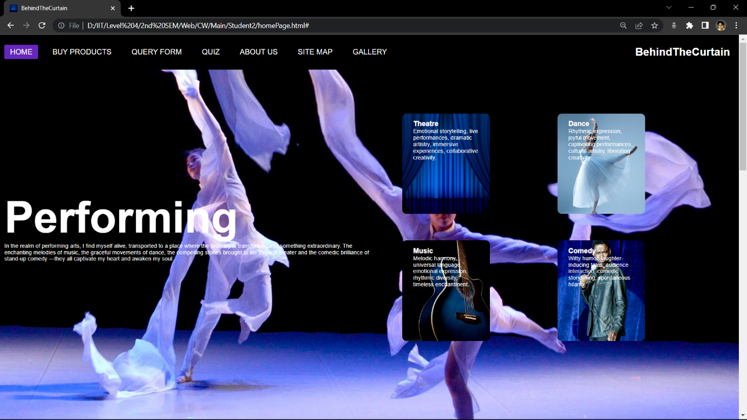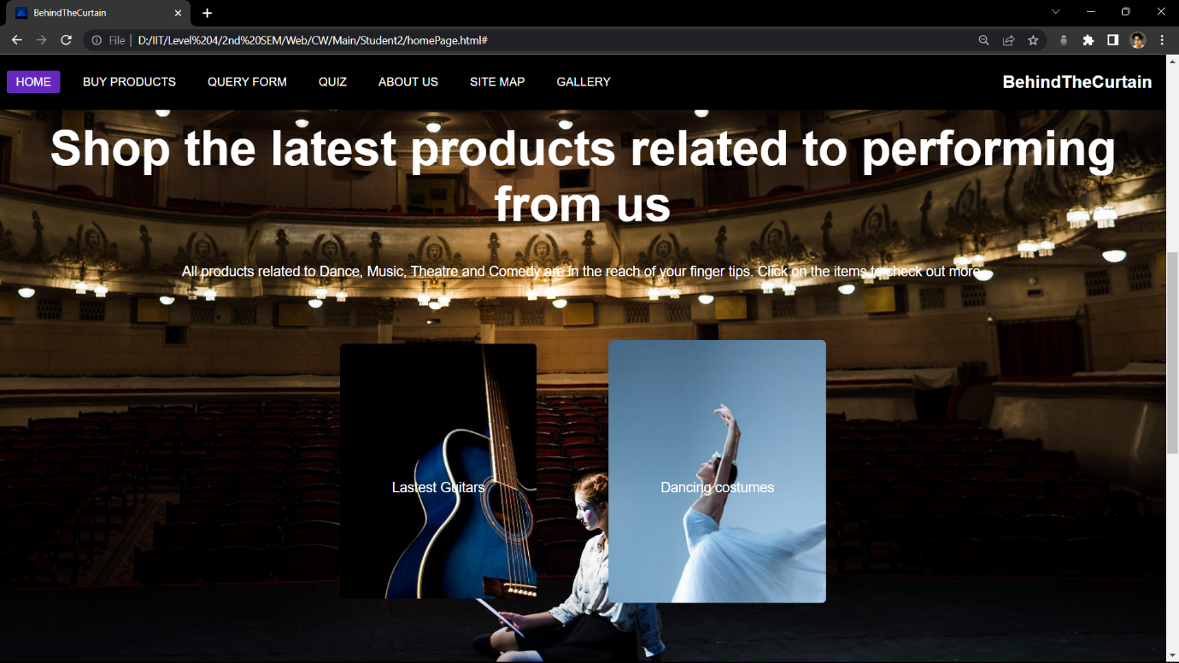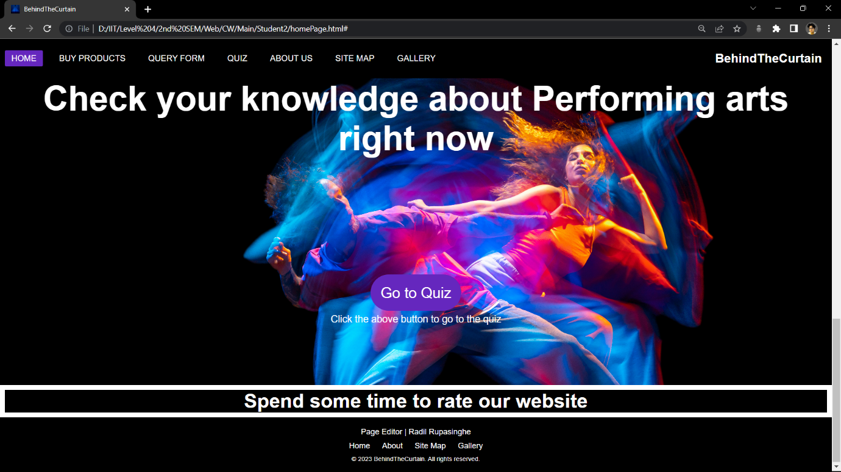

## 

* queryForm.html

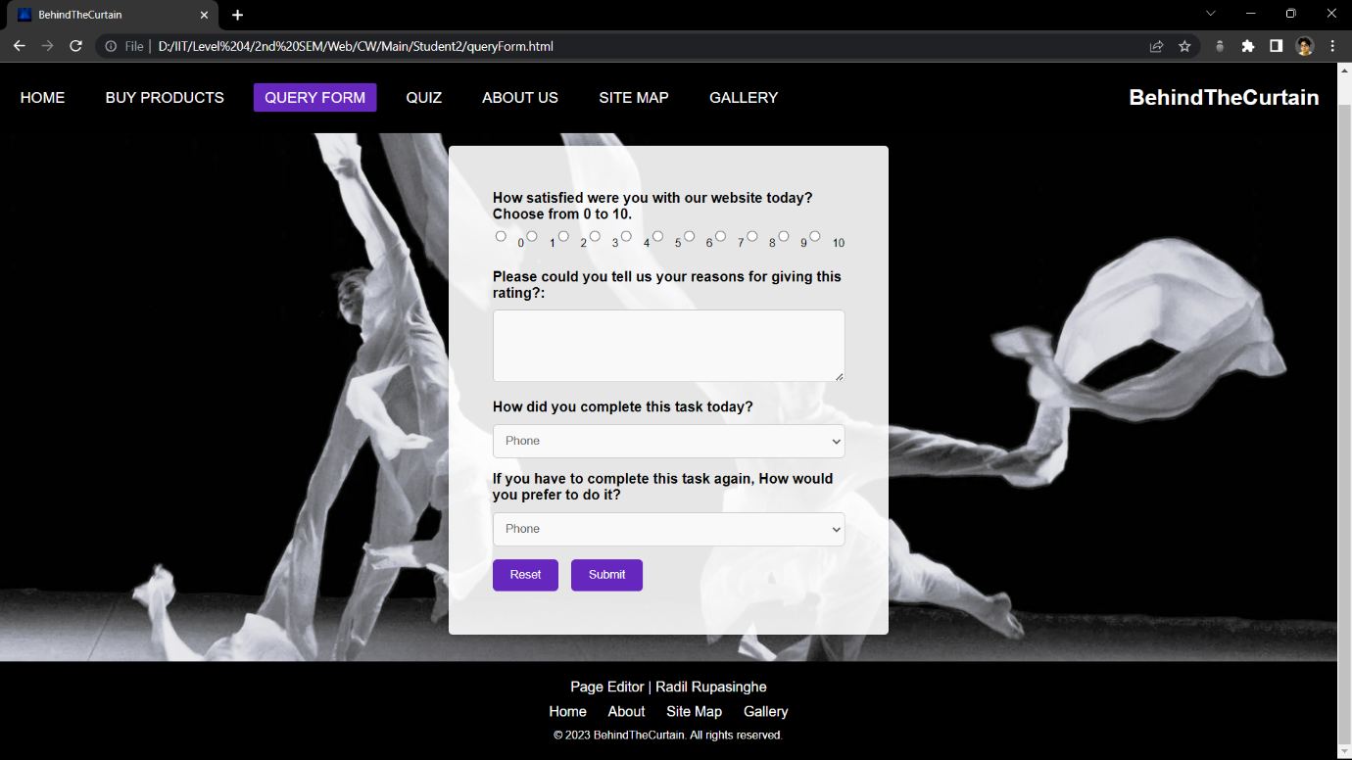

* dance.html

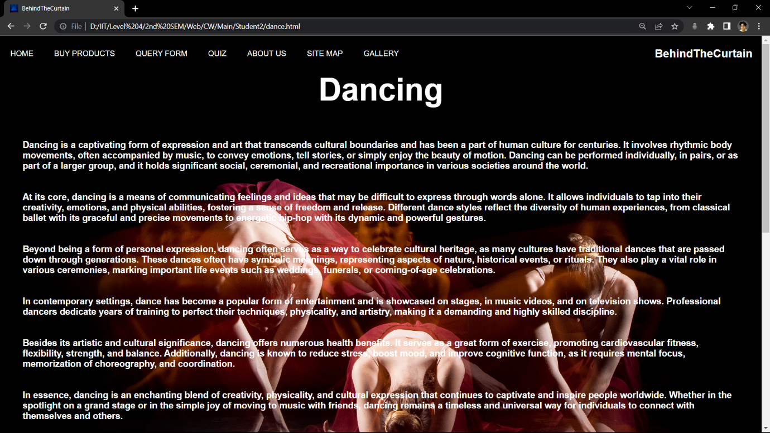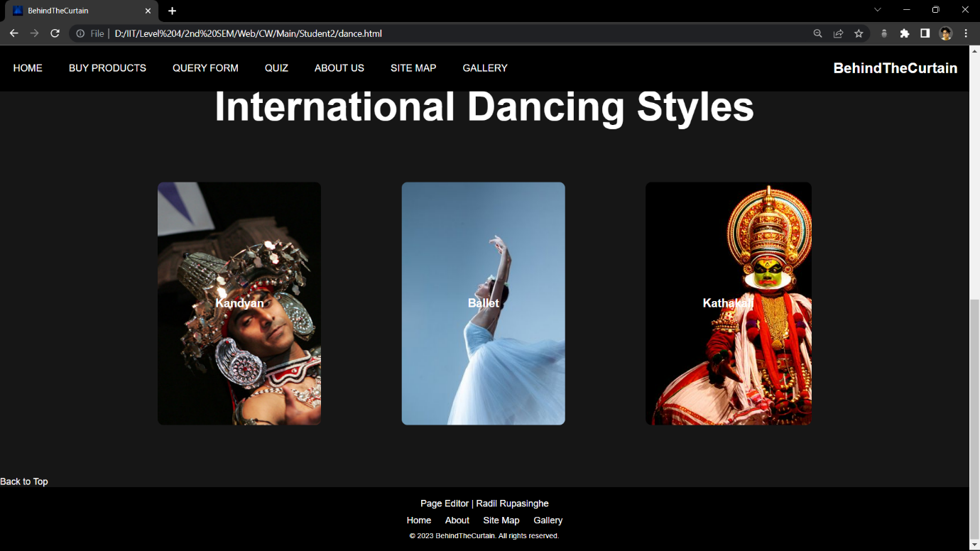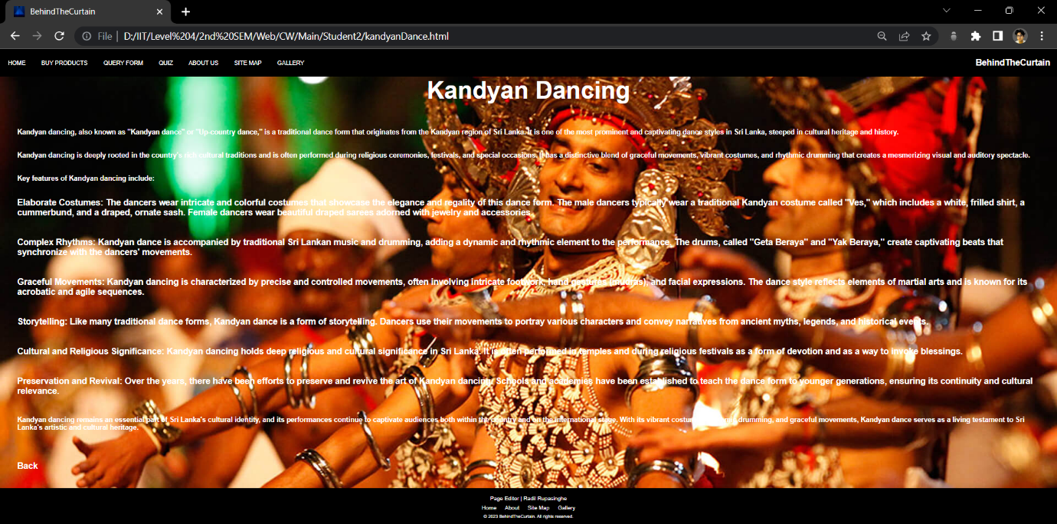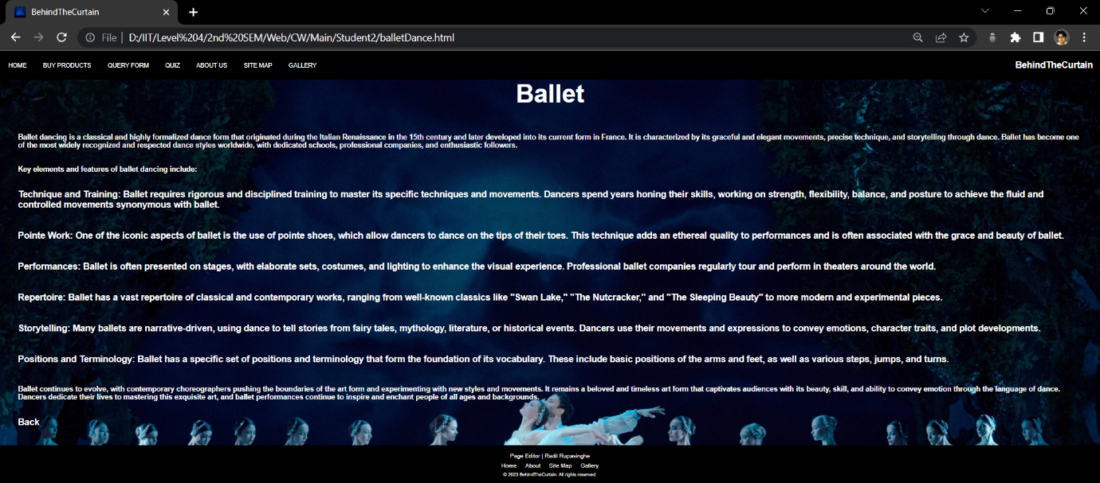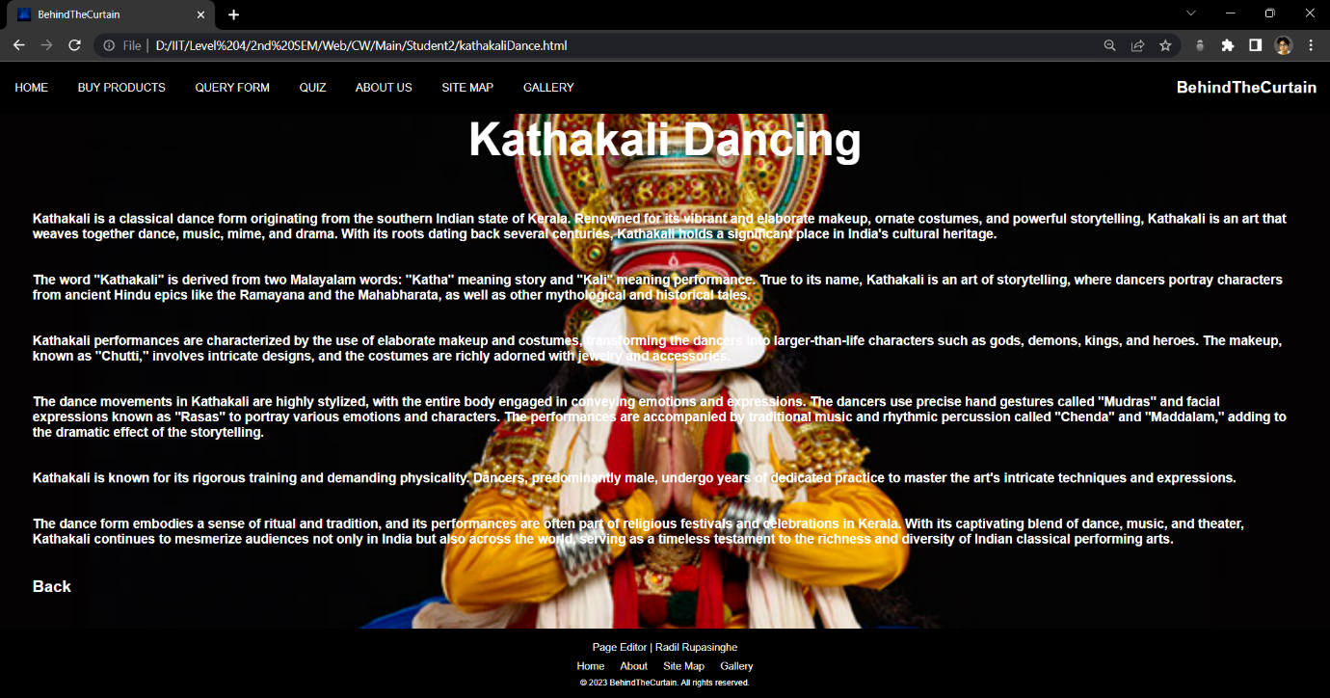

* student2PageEditor.html

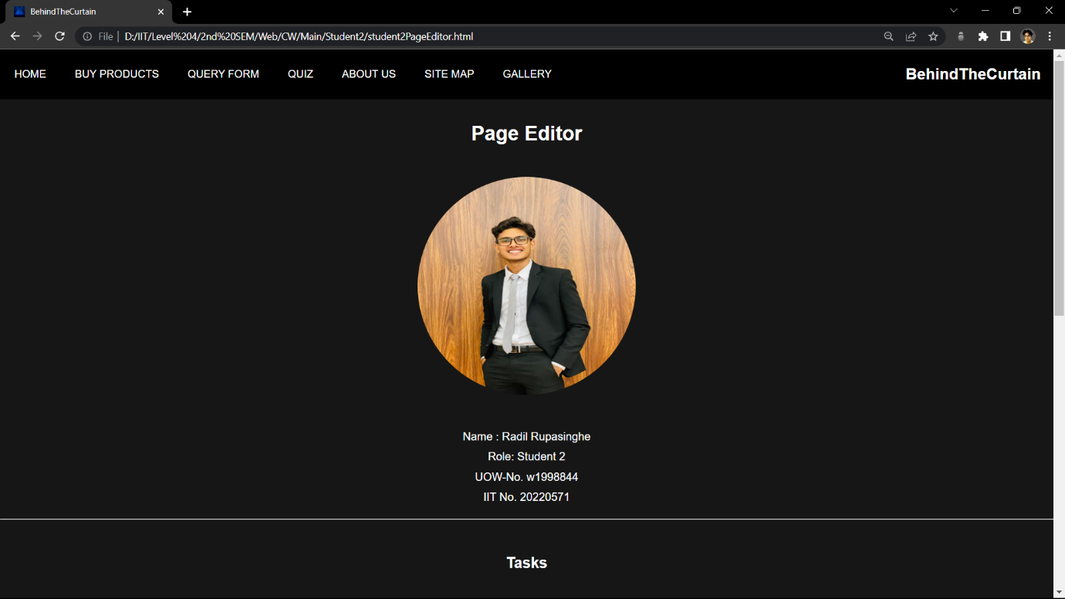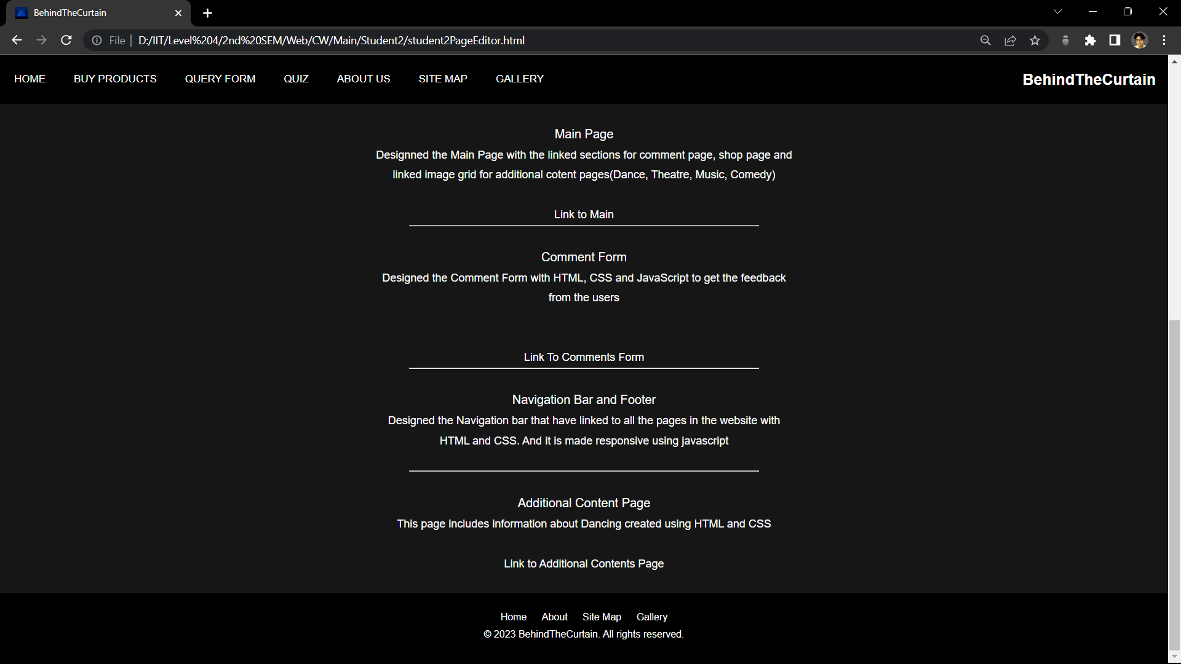

## Appendix C: Screenshots - Webpage Validation Evidence

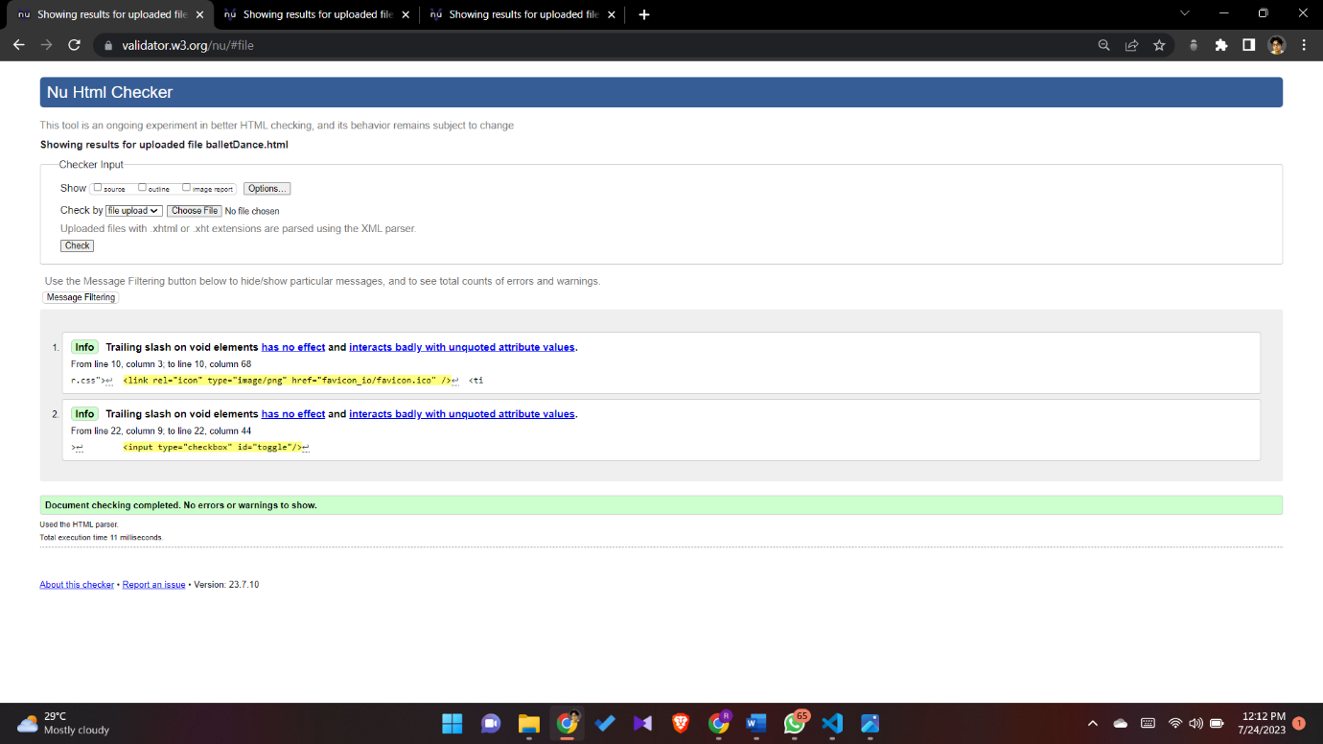

Figure iAdditional content page - page1

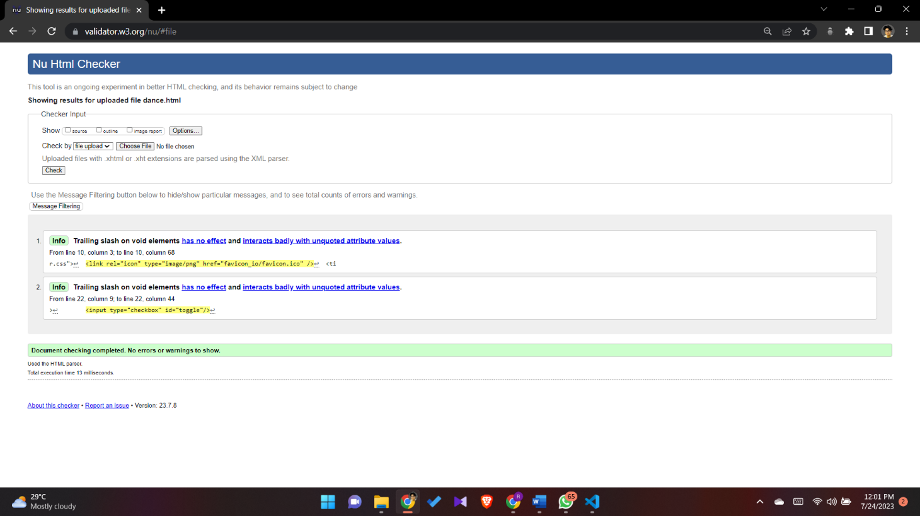

Figure iiAdditional content page

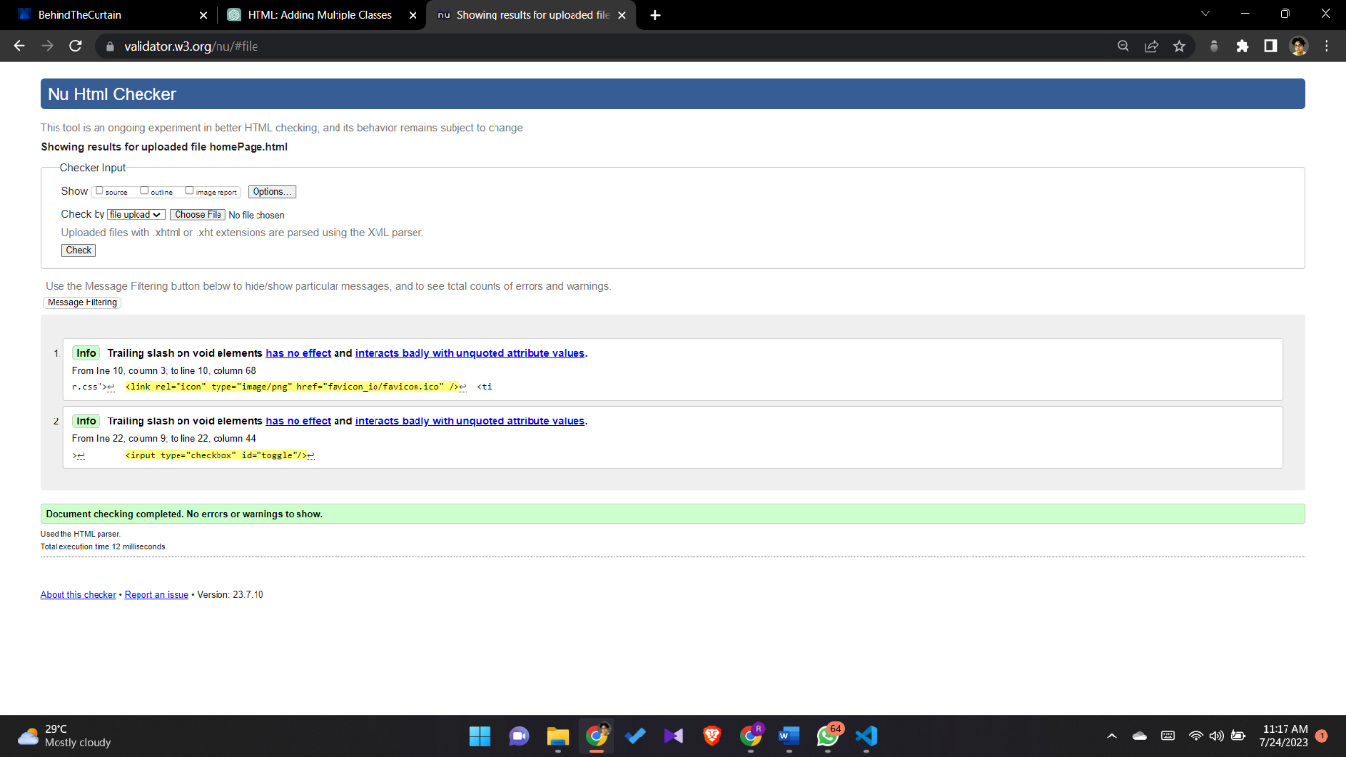

Figure iii Home Page

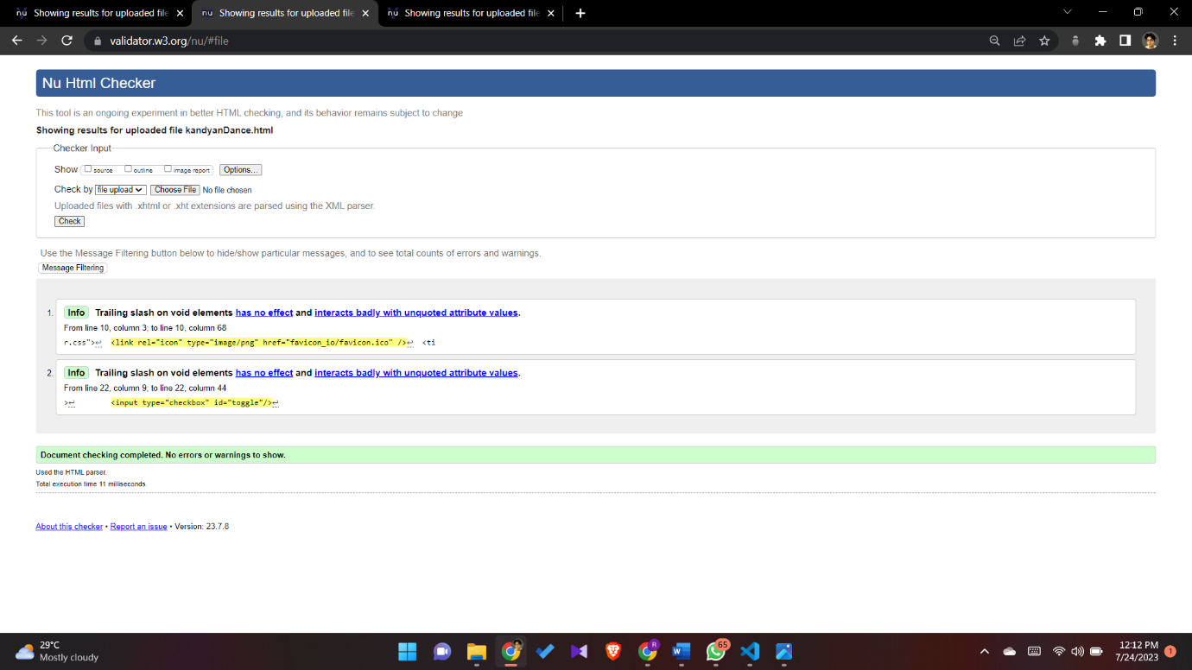

Figure ivAdditional content page - page2

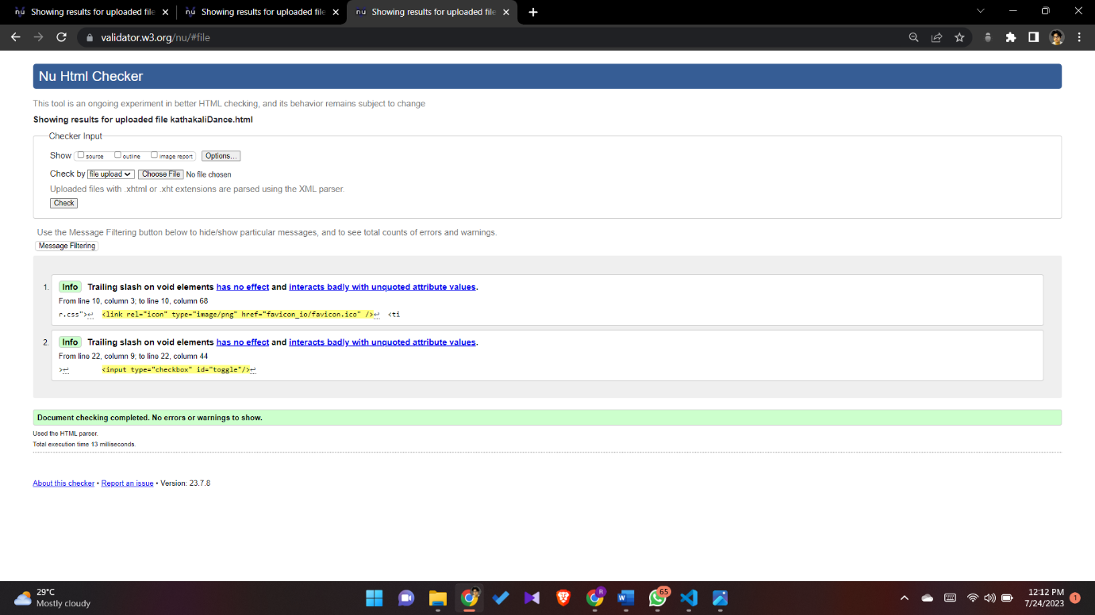

Figure vAdditional content page - page3

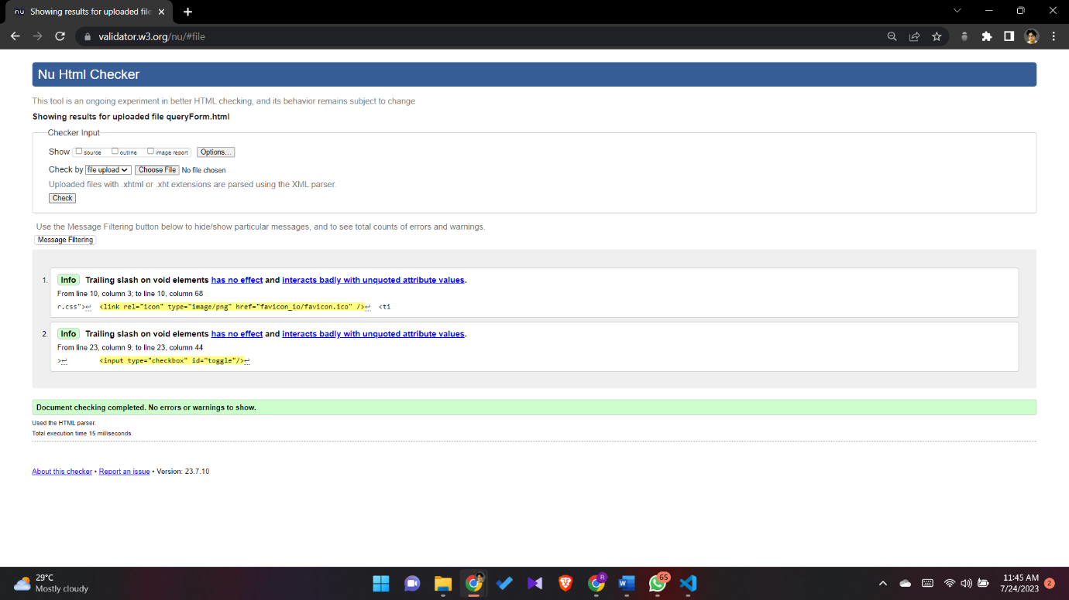

Figure viQuery form / Comments form

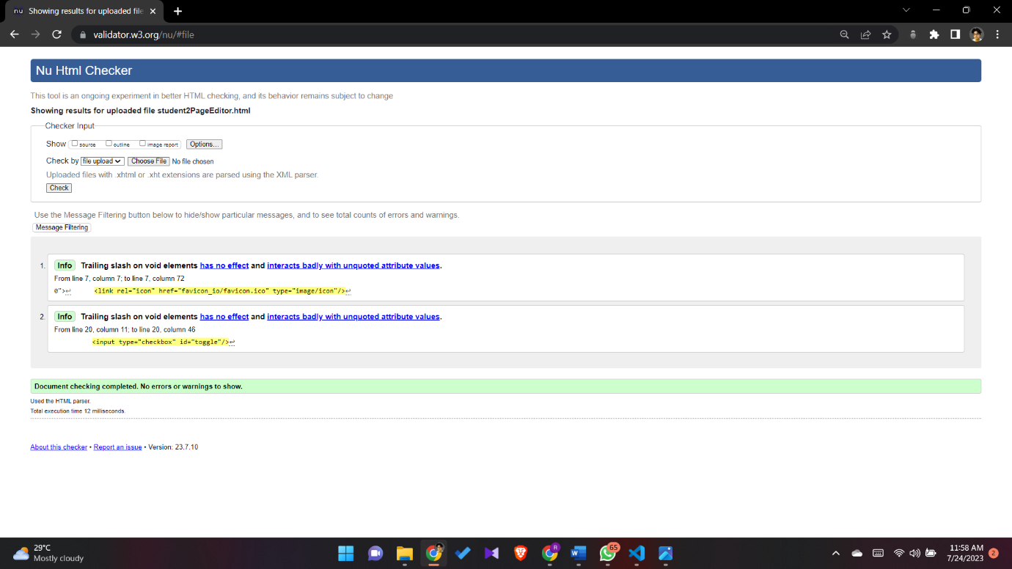

Figure viiPage editor

## Appendix D: Individual Statement

| Student Name: | Radil Rupasinghe | Student Id: | 20220571 |
| --- | --- | --- | --- |
| State what tasks you carried out in the project. | | | |
| Roles of student 2 | | | |
| State what you enjoyed and did not enjoy about teamwork. | | | |
| The team members were easy to collaborate with. It was all fun working with them and learning new things in the meantime. | | | |
| State what you learnt about teamwork. | | | |
| I have worked in teams before but never took the opportunity to lead a team which I took this time and I learned a lot about leadership skills in teamwork in this project. | | | |
| State what skills you gained/learnt from undertaking the project. | | | |
| I was able to broaden my skills about HTML and CSS and also this is my first project using JavaScript which helped me to gain a good idea about it. | | | |
| State any strengths about yourself that emerged whilst undertaking the project. | | | |
| Creativity emerged whilst engaging in this project.  I never knew I had leadership skills before this project. | | | |
| State any weaknesses about yourself that emerged whilst undertaking the project. | | | |
|  | | | |
| State how you would do things better if you were to undertake the project again. | | | |
| I will structure the process to group members and work step by step. The project approach was not that satisfying this time. But we managed to complete the tasks. | | | |
| Additional general or project specific comments: | | | |
|  | | | |

## Appendix E: Task Completion Checklist

Complete the table to indicate if any of your tasks were not completed or partially completed.

|  |  |  |  |  |
| --- | --- | --- | --- | --- |
| **Student 2 Tasks** | **Completed** | | | **Student Comments** |
| **Yes** | **No** | **Partially** |
| 2a - Main (Home) Page | **√** |  |  | **Completed** |
| 2b - Main site navigation | **√** |  |  | **Completed** |
| 3 - Query Form | **√** |  |  | **Completed** |
| 9b - External CSS (9a reused) | **√** |  |  | **Completed** |
| 10 - Extra content page/anchors | **√** |  |  | **Completed** |
| 11 - Page Editor | **√** |  |  | **Completed** |
| 12 - Logo/Page Editor | **X** |  |  | **Partially Completed** |
| 13 - Additional Interactivity | **√** |  |  | **Completed** |
| 14 - Uploaded to Server | **X** |  |  | **-** |